Sbsx Generation and System Arxml Generation
NvM Iteration

Sbsx File Generation:

1) Run the NvM_Configurator_Vxx.jar from “/bin” folder. Load the Excel utility by clicking ‘Browse’ button.
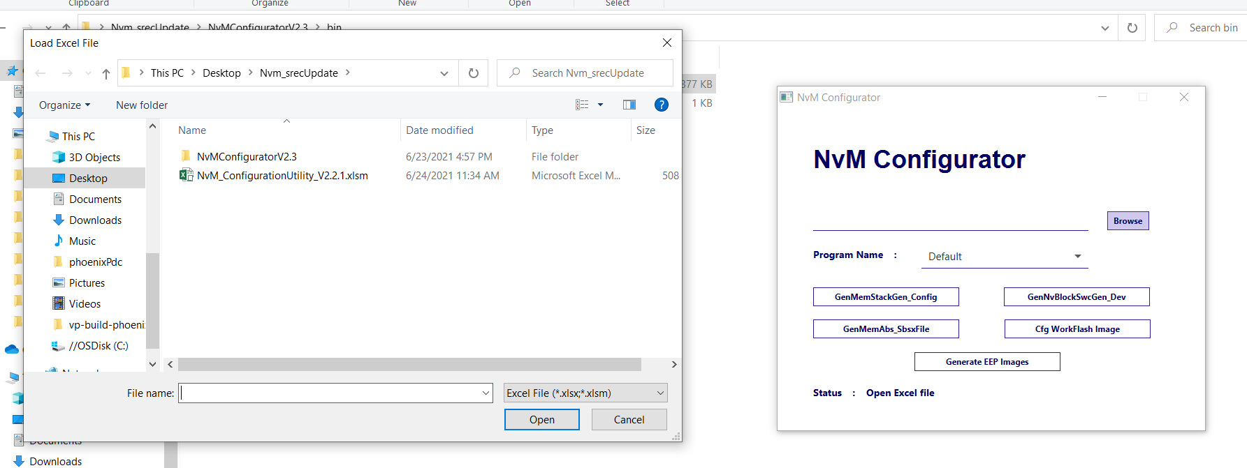

2) After “Reading Excel File Completed” Message is displayed in status, Click GenMemAbs_SbsxFile button.
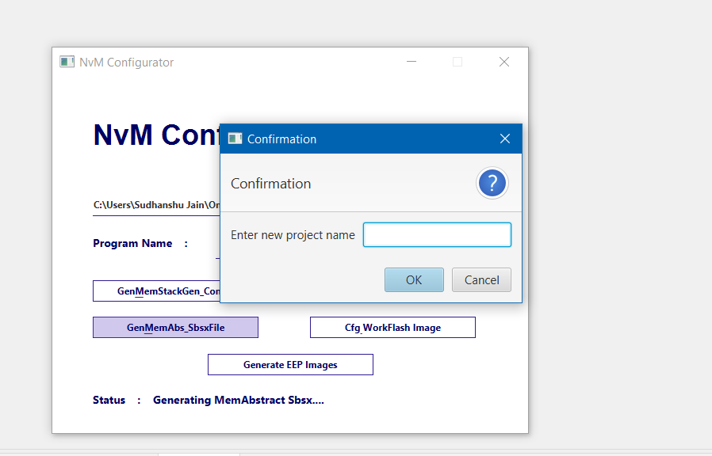
In the Next dialog box enter the project name:
- If you are using vw UML base – Enter “vw” in the box.
- If you are using Ford Bx755 UML base - Enter “FordBx755” in the box.

After Successful generation following will be displayed. Generated File will be located under
“/out/sbsx/” Folder.
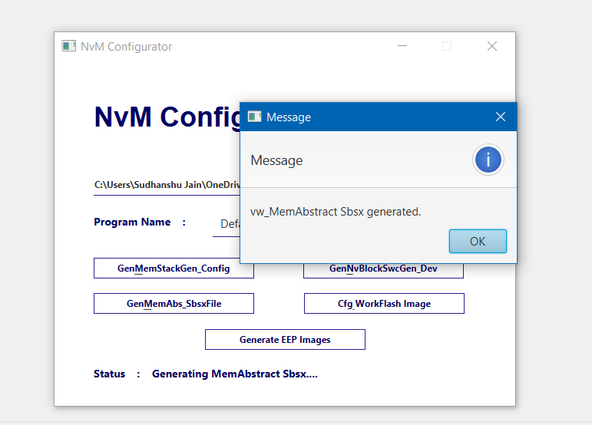

Generating System Arxml from Sbsx File using Rhapsody:

- For Projects with VW UML base for MemAbs:

- Copy the generated Sbsx File to:
“SWA\UML\FordBx755_rpy\C_GlobalDesign\vwfpkb8_MemAbstract” path.

Rename the file to “vwfpkb8_MemAbstract.sbsx”

- Run Rhapsody Project from UML Folder.
Note: Since the vw UML base does not have SWC classes, We need to remove ModeMgr and CmpLib related reference from the Rhapsody Model.

- Locate the vw_MemAbstract Design Unit in the Rhapsody model as in below picture

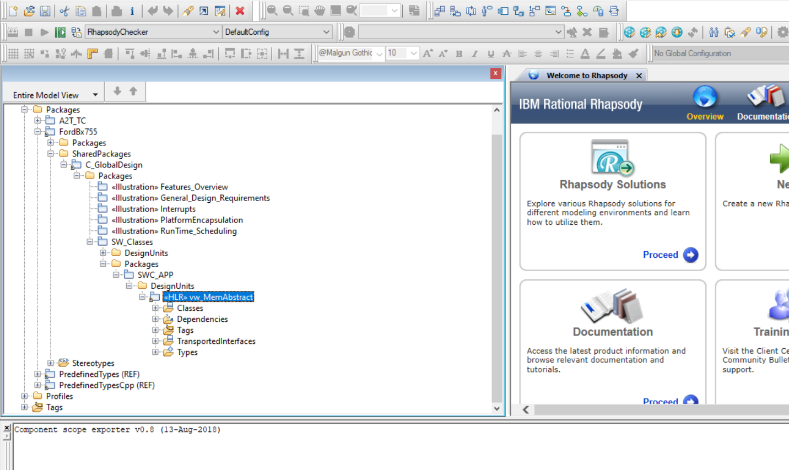

- Expand the Dependencies and delete the ModeMgr as shown below.

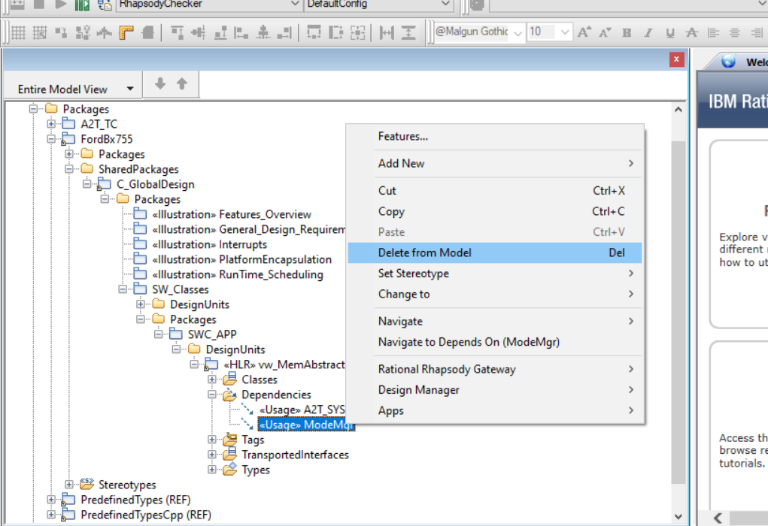

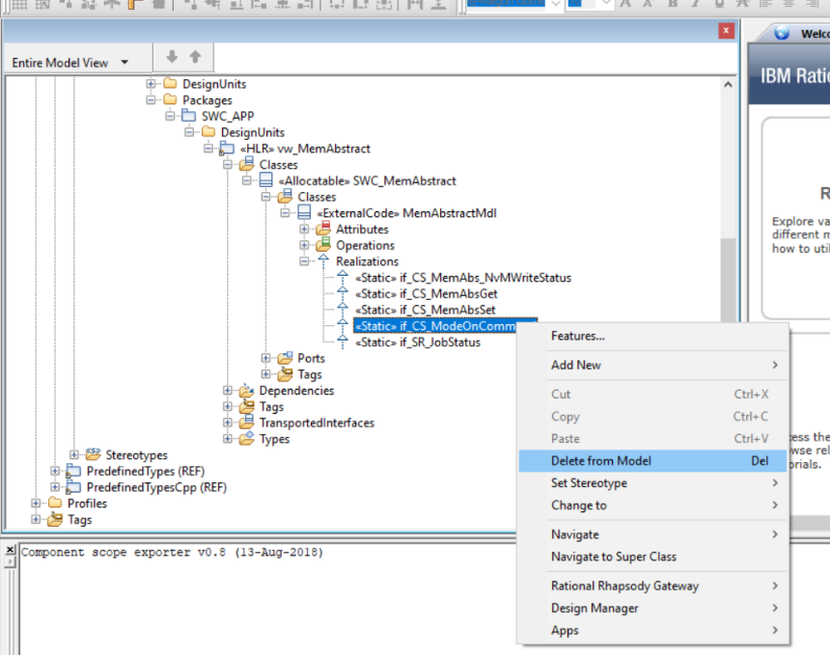
- Expand the Classes Realizations, Then delete “if_CS_ModeOnCommand” Realization.

- Expand Classes Ports and Delete “rp_SR_MeetMode” and “pp_CmpLibCmd_MemAbstractMdl” ports.

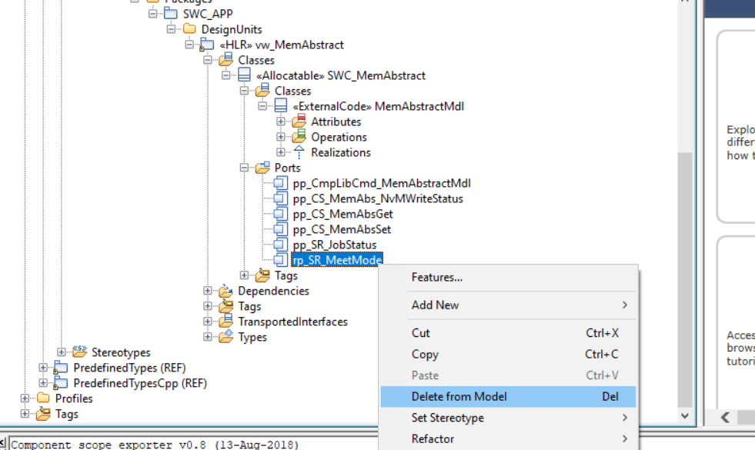

- Expand Classes Operations and delete Operation “CMemAbstractMdl_Impl_OnCommand” from the model.

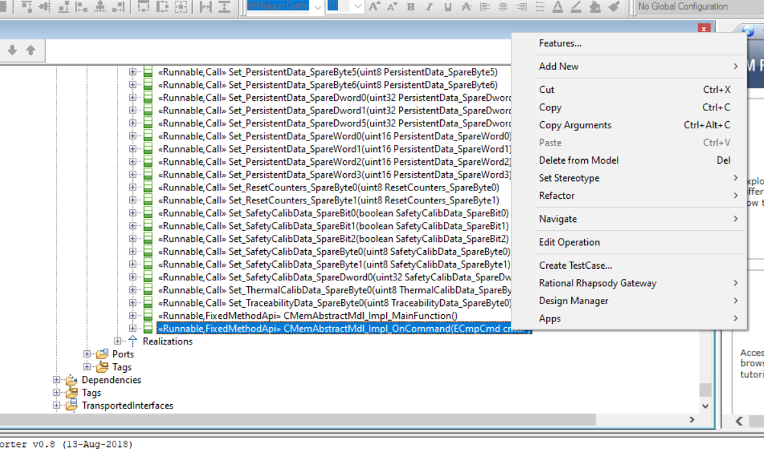

- After performing above steps, Click the Make button in Rhapsody toolbar,
After Successful Make you will get Message shown in below pictures without any errors.
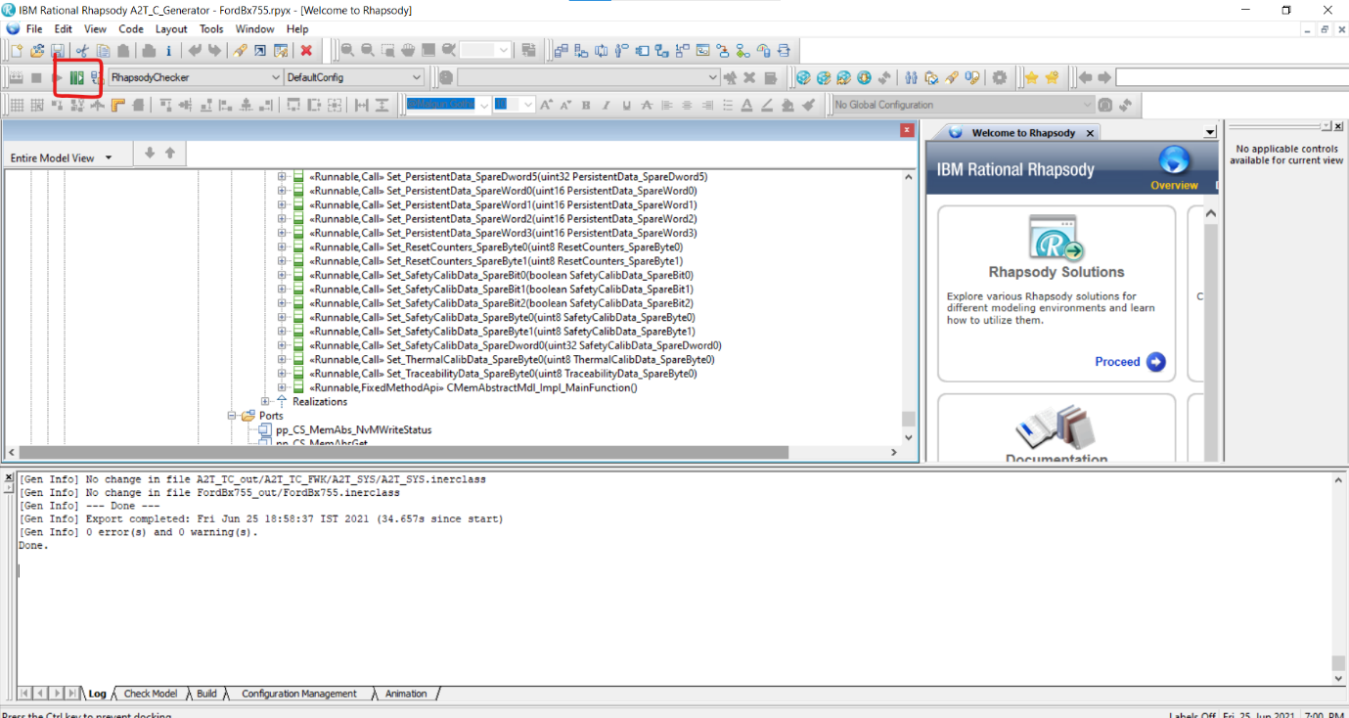

- Go to SWA\WORKSPACES folder and open cmd Prompt – Run “BuildInstance.bat”.
After Successful Arxml generation, generated Arxml Path can be found at location shown in Cmd.

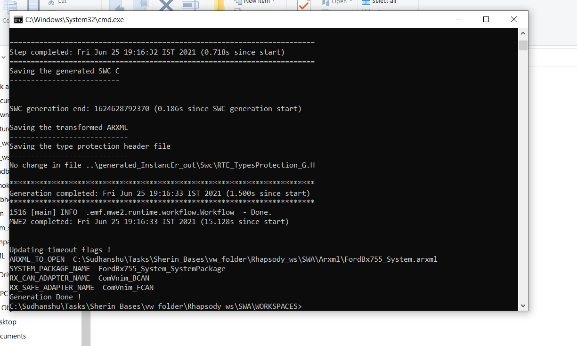

- For Projects with Ford Bx755 UML base for MemAbs:

- Copy the generated Sbsx File to:
“turing-swc-core\turing-swc-core_rpy” path.

Note: The generated sbsx file Name should be - FordBx755_MemAbstract.sbsx

- Run Rhapsody Project from UML Folder.
Note: Since the vw UML base does not have SWC classes, We need to remove ModeMgr and CmpLib related reference from the Rhapsody Model.

- Make the Rhapsody Project using “Make” button in Rhapsody toolbar.
- After Successful make/export from Rhapsody. Run the “BuildInstance.bat” from respective Project WORKSPACE folder.
Eg. - FordBx755_UML_Base\ford_ic_s2dot8_2023_24106_platform_arxml\SWA\WORKSPACES

